**Project Report - Intelligent Financial Planning Hub (Finance Tracker)**

**Tech. Domain –** Data Visualization – Team 4

**Team Members –**

1. P V Shyam Sundar Lal (Team Lead)
2. Abhinandan S Vishwaroop
3. Nivedita Pal
4. Pulicharla Nikhitha

**Overview of the Project**

The **Finance Tracker** is a web-based application designed to help users manage their personal finances by tracking expenses, setting budgets, and generating financial reports. It includes features like user registration and login, expense management (add, update, delete, view), and financial reporting with visualizations. Users can set budget limits for various categories, receive alerts when approaching or exceeding their budgets, and track their financial goals. The application provides a user-friendly dashboard with key financial metrics and real-time updates. The project is divided into modules, with milestones focusing on authentication, expense management, reporting, dashboard visualization, and budget planning.

**Technologies used**

**Frontend :**

**HTML/CSS**: For structuring and styling the user interface.

**JavaScript**: For interactive features and dynamic updates.

**Backend –** Django (Python)

**Database –** MySQL

**Milestones (Completed till week – 5)**

**Milestone – 1 : User Authentication & Expense Management (Weeks 1-3)**

**Module 1: User Authentication**

**Module 1: User Authentication** focuses on implementing secure user registration, login, and logout functionalities. After successful login, users are directed to a personalized dashboard. The module includes form validations, test cases for authentication views, and ensures robust error handling for user authentication services.

**Key Features implemented in this milestone**

1. **User Registration**: This feature allows new users to create an account by providing their details, such as username and password. The system ensures form validation to prevent invalid or duplicate entries.
2. **User Login**: Registered users can securely log in by entering their credentials. Proper error handling ensures users receive feedback for incorrect details or account-related issues.
3. **Dashboard Redirection**: After a successful login, users are taken to their personalized dashboard.

**Screenshots**

* **Home Page**: Welcomes users with a friendly message and provides easy access to login and registration options.

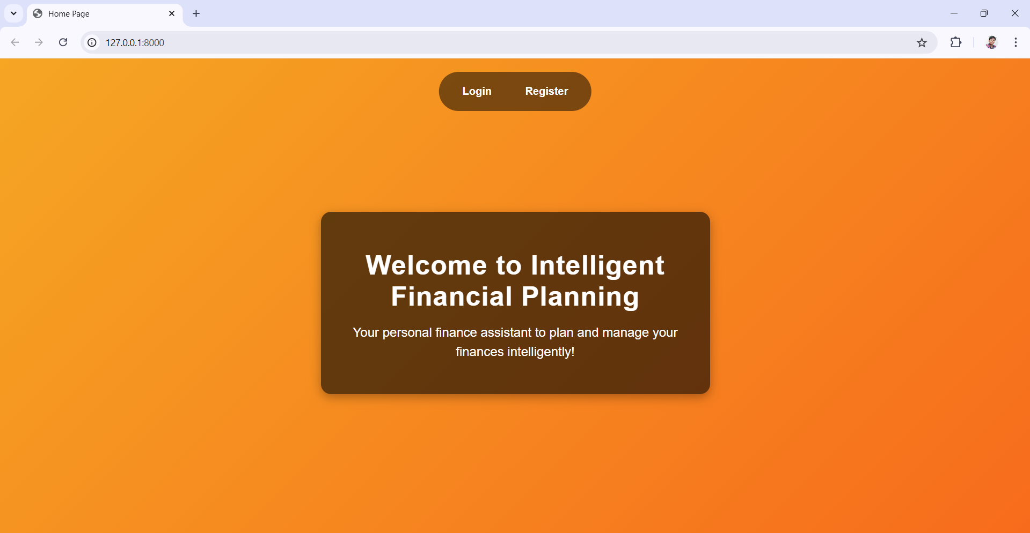

Fig -1 : Home Page

* **Registration Page**: The Registration Page allows new users to create an account by entering details like username and password, with form validations ensuring accurate and secure data entry.

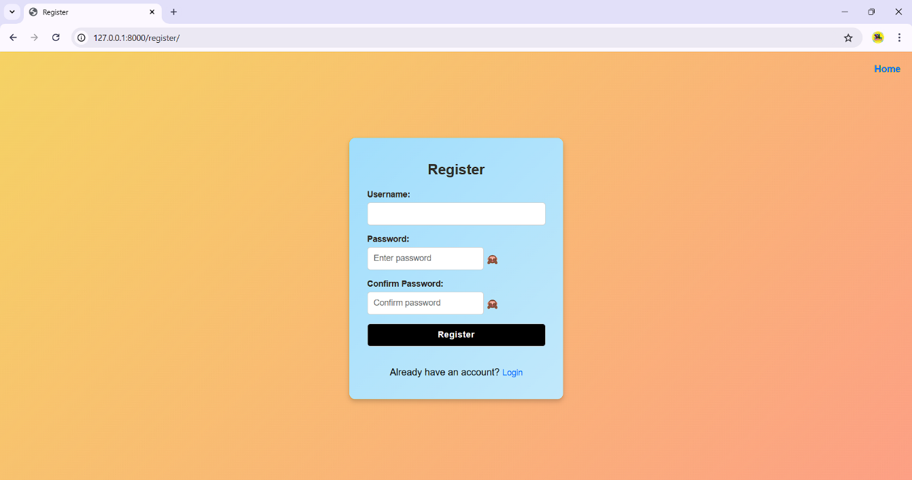

Fig – 2: Registration

* **Login Page** : The Login Page enables registered users to access their accounts by entering valid credentials, with error handling for incorrect inputs and redirection to the profile upon successful login.

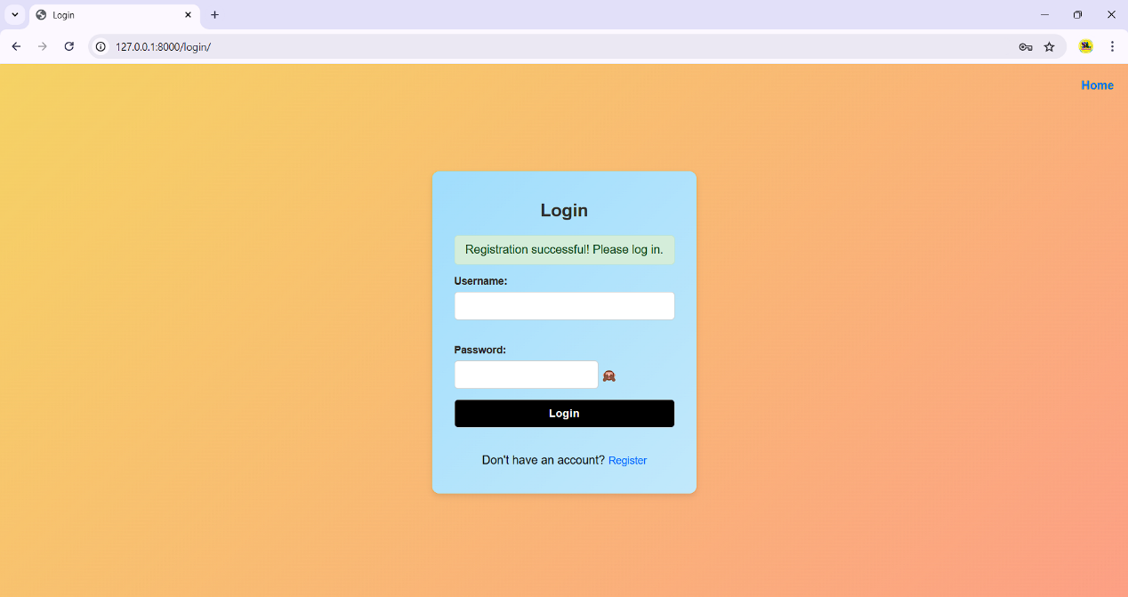

Fig – 3: Login

* **User Profile** : The Profile Page serves as the user's central hub, featuring a menu with options to navigate to the dashboard, add or view expenses, and access detailed financial reports, ensuring seamless functionality and user convenience.

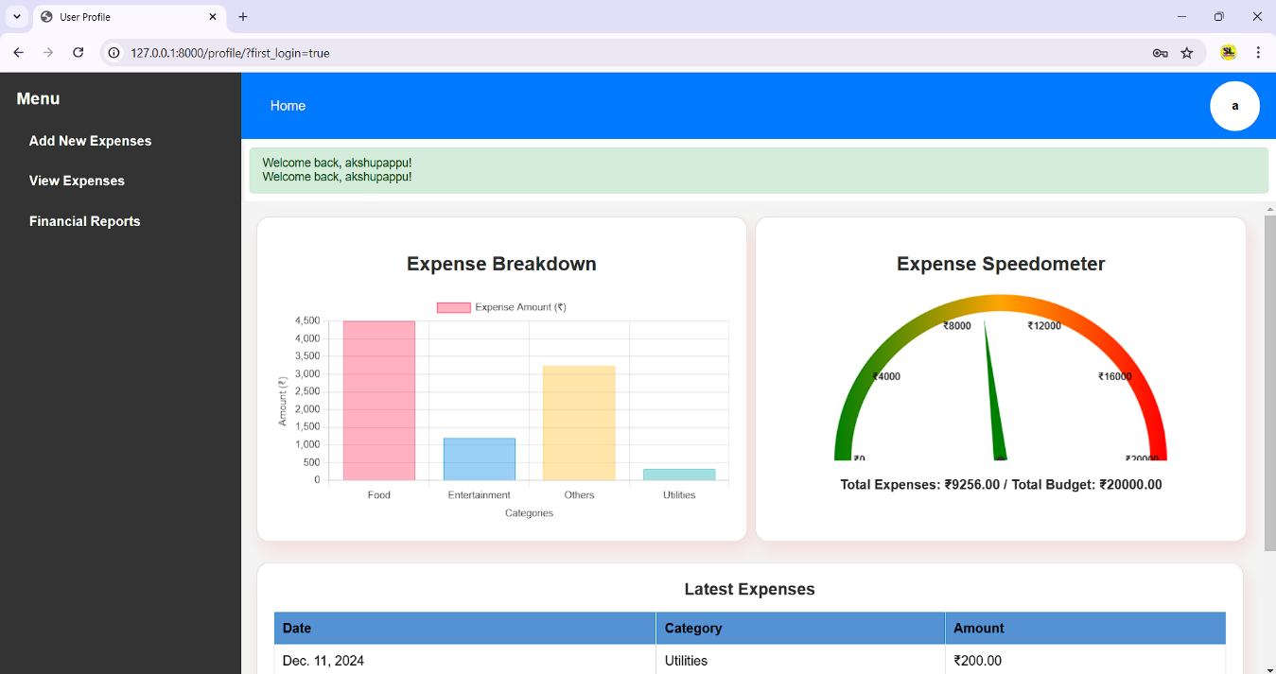

Fig – 4: Profile

**Module 2: Expense Management**

**Module 2: Expense Management** involves designing a database to store expense data, providing an interface for users to add, update, view, and delete expenses. It includes backend functionality for managing expense operations, form validations, and comprehensive test cases to ensure the reliability of expense-related services.

**Key Features implemented in this module**

1. **Add Expenses**: Users can record their expenses by entering details such as amount, category, date, and description.
2. **View Expenses**: A comprehensive list of all recorded expenses is displayed, allowing users to track their spending history easily.
3. **Edit or Delete Expenses**: Users can update existing expense details or remove them entirely, offering flexibility and control over their financial data.

**Screenshots**

* **Add Expenses** : Users can enter their expenses with details like amount, category, date and description.

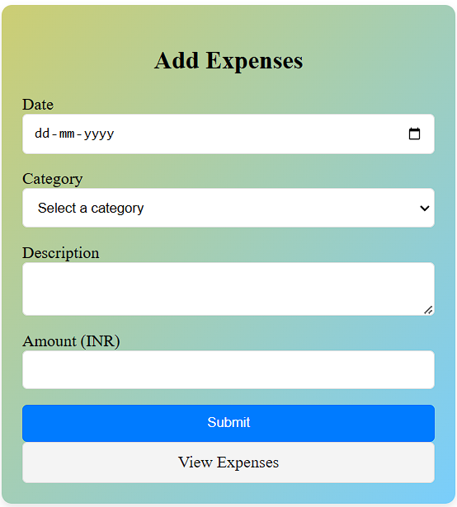

Fig – 5: Add Expenses

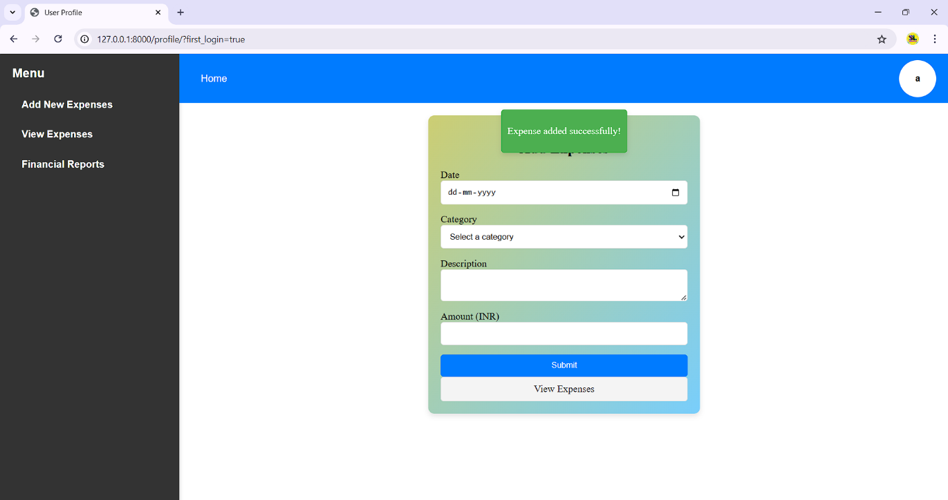

Fig – 6: Expense Added Successfully

* **View Expenses** : allows users to see a list of all their recorded expenses, displaying key details like amount, category, and date. This feature helps users track their spending patterns and manage their finances effectively.

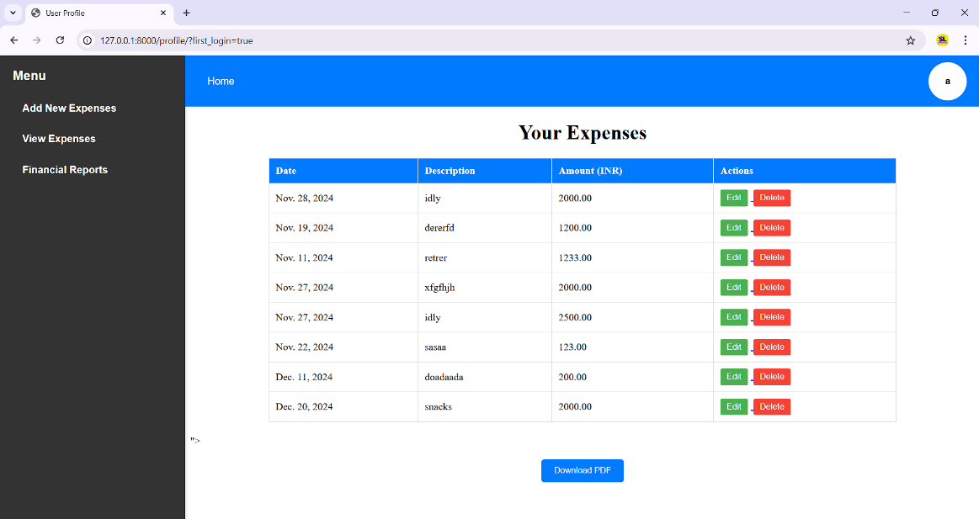

Fig – 7: View Expenses

* **Update Expenses** : This enables users to edit existing expense entries by modifying details like amount, category, or description, or to delete any expense they no longer wish to track, providing flexibility in managing their financial records.

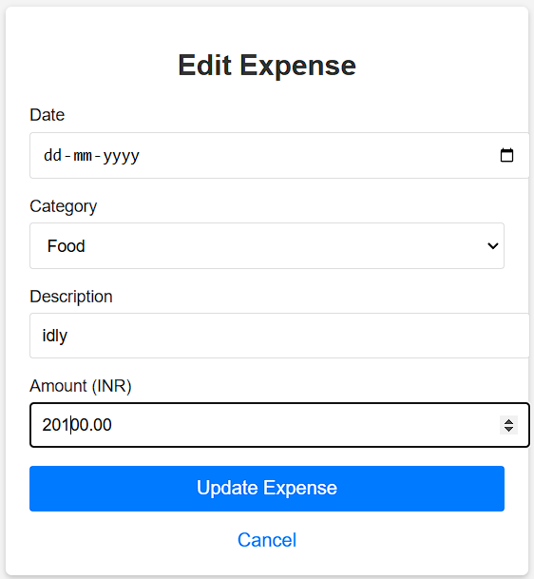

Fig – 8: Update Expenses

**Milestone – 2 : Financial Reporting (Weeks 4-5)**

**Module 3: Financial Reporting**

Module 3focuses on creating an interface for users to generate detailed financial reports, allowing them to select custom date ranges. It includes backend logic for calculating expense totals and averages, along with visualizations like charts and graphs to represent spending patterns. The module also supports exporting reports as PDFs and ensures accurate functionality with test cases and form validations.

**Key Features implemented in this module**

1. **Report Generation**: Users have the ability to generate reports.
2. **Expense Calculation**: The system computes the total and average expenses for the expenses.
3. **Visualizations**: Spending patterns are displayed through charts and graphs, such as pie charts for categories and line charts for monthly expenses.
4. **PDF Export**: Users can download their financial reports in PDF format for offline access.

**Screenshots**

* **Financial Reports** : Reports in the system provide users with detailed insights into their spending patterns.

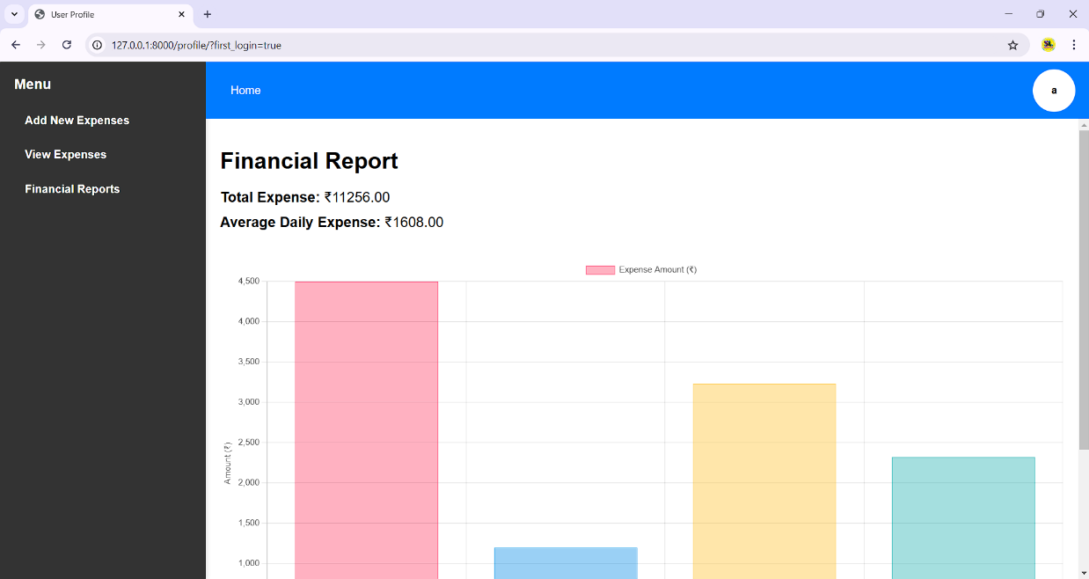

Fig – 9: Reports

* **PDF Export** : For PDF export, JavaScript, along with the **jsPDF** library, is used to generate PDF files directly in the browser. It fetches the user's expense data and visualizations, then compiles them into a downloadable PDF report, which is saved under the name **"financial_expenses.pdf"** for easy access and sharing.

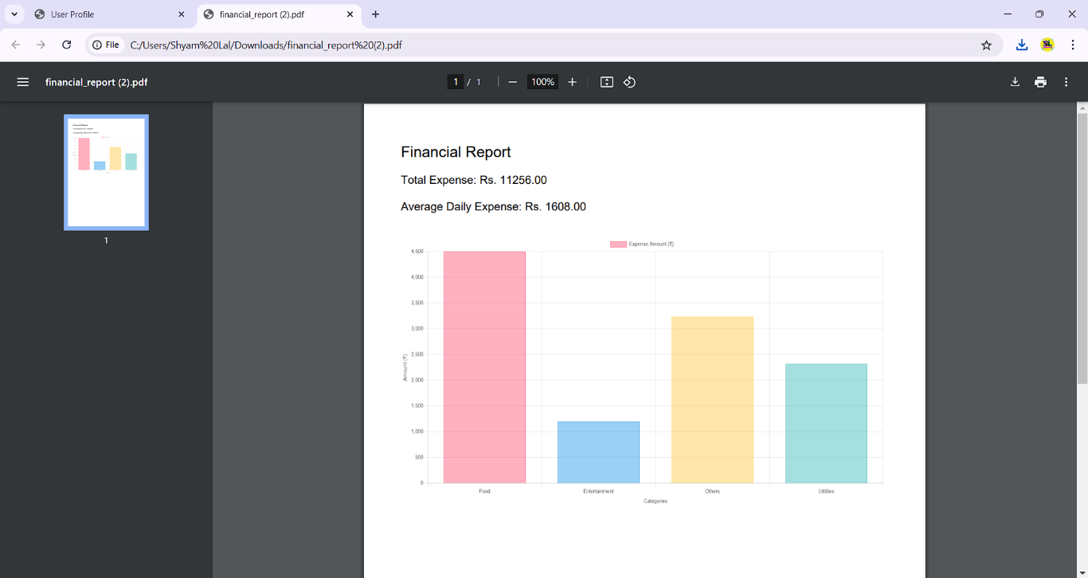

Fig – 10: PDF Export of the Financial Report

* For **PDF export** of the **View Expenses** section, JavaScript with the **jsPDF** library is used to generate the PDF file. The report, containing the user's expense details, is saved with the filename formatted as **"_expenses_list.pdf"**, making it personalized and easy to identify.

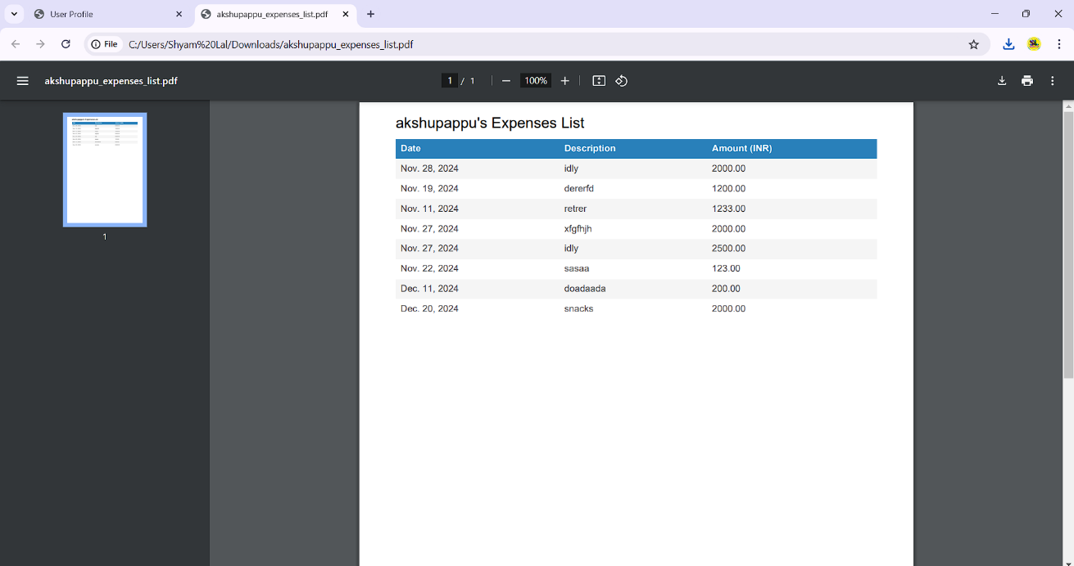

Fig – 11: PDF Export of the View Expenses